
FIELD TRIP REPORT TO KORLEBU TEACHING HOSPITAL.

FOR THE PROGRAMME OF STUDY OF BSc COMPUTER SCIENCE (CYBERSECURITY OPTION)
OF THE COMPUTER SCIENCE DEPARTMENT
OF GHANA COMMUNICATION TECHNOLOGY UNIVERSITY
BY
INDEX NO: 1704895585
NAME: EMMANUELLA NANA AMA WEIR

LECTURER: DR. MARTIN MABEIFAM UJAKPA.
JANUARY 2026.

Table Of Contents
List of Figures iii
List of Tables iv
Abstract v
1.1. INTRODUCTION 1
1.2 INDUSTRY: Health 1
1.3 COMPANY: Korle-bu Teaching Hospital 2
1.3.1 DEPARTMENT: It/Health Information Systems 2
1.4 Operations, Activities and Resources 2
1.5 Operational Effectiveness and Efficiencies of Korle-bu 3
1.5.1 CHALLENGES 3
1.5.2. ANALYSIS 4
1.5.3 PROPOSED SOLUTION 4
1.5.4 EXPECTED BENEFITS. 4
1.6 Proposed Solution Specifications and Design 4
1.6.1 Agile Methodology 4
1.6.2 Requirement Analysis 5
1.6.2.1 Functional Requirements 5
1.6.2.2 Non-functional Requirements 5
1.6.2.3 Hardware Requirements 6
1.6.2.4 Software Requirements 6
1.6.2.5 Sprints and Iterations 6
1.6.2.6 User Stories 6
1.6.2.7 Continuous Integration and Testing 7
1.6.2.8 Adaptability to Change 7
1.6.3 System Design 7
1.6.3.1 System Architecture Diagram 7
1.6.3.2 Use Case Diagram 8
1.6.3.3 Sequence Diagram 9
1.6.3.4 User Interface Design 9
1.7 PROPOSED SOLUTION DEVELOPMENT 10
1.7.1 DEVELOPMENT TECHNOLOGY AND TOOLS SPECIFICATIONS 11
1.7.1.1 Software (Programming Language, IDE and runtime) 11
1.7.1.2 Hardware (for development and runtime) Development machines 12
1.7.2 NETWORK SPECIFICATIONS 14
1.7.2.1 Network specifications Transport security and access control 14
1.7.2.2 DEVELOPED SOLUTION AND ASSOCIATED CODE 15
1.8 SYSTEM TESTING 17
1.8.1 Unit Test Scope and purpose 18
1.8.2 Integration Testing Scope and purpose 18
1.8.3 System Testing Scope and purpose 19
References 24

List of Figures
Figure 1 SYSTEM ARCHITECTURE DIAGRAM 8
Figure 2 USE CASE DIAGRAM 9
Figure 3 SEQUENCE DIAGRAM 9
Figure 4 MAIN INTERFACE 17
Figure 5 PROCUMENT PAGE 18
Figure 6 CATALOG PAGE 18
Figure 7 PROCUMENT ACQUISITION FORM 19
Figure 8 CODE FOR MAIN INTERFACE 20
Figure 9 CODE FOR ACTION CENTER 20
Figure 10 CODE FOR AUTHENTICATION 21
Figure 11 CODE FOR CATALOG 22
Figure 12 CODE FOR DASHBOARD 22
Figure 13 CODE FOR MENU HEADERS 23
Figure 14 CODE FOR LANDING PAGE 23

List of Tables

Abstract
This field trip report records observations made at Korle-Bu Teaching Hospital with a focus on the hospital’s IT / Health Information Systems and the procurement workflow for clinical and IT equipment. The visit revealed a largely manual procurement process that produces delays, increases operational risk and reduces auditability. To address these gaps the report proposes a digital Procurement Request and Approval System (PRAS) built with a three-tier architecture (React frontend, Django REST API, PostgreSQL data tier). The system specification, development approach (Agile), required technology and hardware, network considerations, delivered code artefacts and a comprehensive testing plan (unit, integration and system testing) are detailed to enable a secure, maintainable pilot and eventual production deployment.

1.1. INTRODUCTION
Field trips form an essential component to experiential learning within computing and cyber security. They provide students with the opportunity to observe how organizations operate in the real world operate, how technological processes are implemented, and how cyber security principles are applied within practical work environments. For students pursuing a Bachelor of Science in Cyber security, these visits bridge the gap between theoretical course work and industry practices, fostering a deeper understanding of organizational systems, digital operations and security challenges.
The purpose of this field trip exercise is to explore the structure, operations, and technological frameworks of selected firm in the Health Industry. By engaging directly with industry professionals and observing active technological systems, the exercise helps to highlight how organizations deploy, secure and maintain their digital infrastructure. More importantly, it enables the identification of operational challenges and cyber security vulnerabilities.
This report focuses on one selected hospital within Health Industry named KORLE-BU TEACHING HOSPITAL and specifically examines its Information Security and Infrastructure Department. The content presented is based on observations made during the field visit, interactions with technical personnel, and an assessment of the hospital's operational structure and security practices. The report provides an overview of the industry, the firm, and the department understudy, leading to a detailed analysis of challenges observed and proposed solutions aligned with cyber security best practices.

1.2 INDUSTRY: Health
The health industry in Ghana comprises public, private, and faith-based institutions that collectively deliver essential medical services to the population. This sector plays vital roles such as disease prevention, diagnosis, treatment, emergency response, maternal and child healthcare, and control of public health threats. In addition, health institutions are responsible for the management of patient information, including the accurate collection, storage, and protection of medical records and health data. Effective data handling supports clinical decision-making, improves service delivery, ensures continuity of care, and helps facilities meet regulatory standards for confidentiality and data security. Overall, the health industry remains central to safeguarding public health while maintaining reliable health information systems that support national development.

1.3 COMPANY: Korle-bu Teaching Hospital
Korle-bu Teaching Hospital is Ghana’s largest and premier referral hospital, located in Accra. Established in 1923, it serves as the main teaching hospital for the University of Ghana Medical School and plays a central role in training doctors, nurses, and other health professionals. As a tertiary facility, it provides highly specialized services such as cardiothoracic surgery, renal dialysis, oncology, plastic surgery, and advanced diagnostic care. The hospital also manages a large volume of patient information, ensuring proper handling of medical records for accurate diagnosis, continuity of care, and compliance with data protection standards. Korle- Bu remains a key pillar in Ghana’s health system, offering advanced medical care, supporting medical research, and contributing significantly to national healthcare development.

1.3.1 DEPARTMENT: It/Health Information Systems
The IT/Health Information Systems Department is responsible for managing the hospital’s technological infrastructure and ensuring the smooth flow of digital information across all units. Their core role is to support clinical and administrative operations by maintaining computer systems, networks, hospital software, and electronic health record platforms. This department ensures that patient data is accurately captured, securely stored, and readily accessible to authorized healthcare professionals. They also implement cyber security measures to protect sensitive health information from breaches, unauthorized access, and data loss. Additionally, the department supports digital services such as telemedicine, diagnostic imaging systems, data analytics, and internal communication platforms. Overall, the IT/Health Information Systems Department plays a vital role in improving efficiency, enhancing patient care, and ensuring compliance with data protection regulations.

1.4 Operations, Activities and Resources
Korle-bu Teaching Hospital operates as Ghana’s premier tertiary referral and teaching facility, providing advanced clinical care, medical training, and research services to support the country’s health system. Some operations include specialized diagnostics, surgical procedures, maternal and child healthcare, emergency services, and the treatment of complex medical conditions referred from across the nation. It undertakes key activities such as clinical service delivery, professional training for medical and allied health students, medical research, and comprehensive health information management, which involves the secure handling of patient data and the use of digital health systems to support accurate decision-making. Korle-bu’s resources include a highly skilled workforce of medical specialists, nurses, pharmacists, laboratory professionals, and IT personnel, supported by modern physical and technological assets such as specialized centers, advanced diagnostic equipment, operating theatres, and electronic health record systems. These combined operations, activities, and resources enable the hospital to deliver high-quality healthcare while fulfilling its mandate as a national center of excellence.

1.5 Operational Effectiveness and Efficiencies of Korle-bu
During my field trip to Korle Bu Teaching Hospital, it became evident that the facility demonstrates strong operational effectiveness and efficiency through its well-coordinated clinical services, specialized units, and use of structured health management systems. The hospital’s ability to provide advanced medical care is supported by skilled specialists, modern diagnostic equipment, and clearly defined clinical protocols that enhance the accuracy and quality of patient treatment. Efficiency is further improved by the integration of health information systems, which streamline the handling of patient records, reduce waiting times, and facilitate smooth communication across departments. Additionally, the hospital’s commitment to continuous professional training, multidisciplinary teamwork, and the organized use of its physical and technological resources contributes to timely service delivery and improved patient outcomes.

1.5.1 CHALLENGES
Korle-bu Teaching Hospital faces several challenges that affect its ability to operate at full efficiency. One of the major issues is the delay in procurement of devices. Delays in procuring medical devices can disrupt hospital operations by slowing down diagnosis, treatment, and essential procedures. Without timely equipment, staff may be forced to use outdated tools, leading to longer waiting times, reduced efficiency, and potential risks to patient safety. These delays can also increase congestion in departments and negatively affect overall healthcare delivery.

1.5.2. ANALYSIS
Delays in the procurement of medical devices often stem from slow approval processes, limited budgets, supplier issues, and poor coordination between hospital departments. These delays disrupt hospital operations by slowing diagnosis and treatment, increasing patient waiting times, and forcing staff to rely on outdated or inadequate equipment. As a result, overall efficiency and quality of care decline, and the hospital may incur higher costs due to emergency purchases or frequent repairs.

1.5.3 PROPOSED SOLUTION
A system to automate the procurement of manual flow in items.

1.5.4 EXPECTED BENEFITS.
Automating the manual procurement process for hospital devices offers several important benefits. It speeds up the approval and ordering stages, reduces human errors, and provides clear tracking of requests in real time. Automation also improves communication between departments, enhances record-keeping for audits, and supports better budgeting. By streamlining workflows and preventing delays in obtaining essential equipment, the system ultimately improves operational efficiency and supports better patient care

1.6 Proposed Solution Specifications and Design
The proposed solution is a digital procurement system designed to automate and streamline the process of acquiring medical and IT devices at Korle-bu Teaching Hospital. This system will replace the inefficient manual workflow, providing a transparent, efficient, and accountable platform for all procurement activities, from request initiation to final delivery and approval.

1.6.1 Agile Methodology
To ensure the successful development of the procurement automation system, the Agile methodology is selected as the most appropriate approach (Fowler, 2004). Agile is an iterative and flexible project management framework well-suited for developing solutions where requirements may evolve. Its core principles align perfectly with the need to deliver value quickly and adapt to feedback from hospital staff. This approach allows for the system to be developed in small, incremental cycles (sprints), facilitating the rapid delivery of functional components. Agile emphasizes continuous collaboration between the development team and key stakeholders, and this feedback process will be managed using tools like GitHub Projects, which provides Kanban boards to visualize sprint progress and track tasks transparently. The hospital's dynamic environment means that requirements may change, and the Agile approach allows for these adjustments to be incorporated throughout the development process (Sommerville, 2016).

1.6.2 Requirement Analysis
The requirement analysis phase defines the specific capabilities and characteristics of the proposed procurement system. It involves identifying what the system must do (functional requirements) and the quality standards it must meet (non-functional requirements) to be successful.

1.6.2.1 Functional Requirements
The system will provide role-based access to ensure users only interact with relevant functions. Standard users can create and submit new procurement requests, specifying item details, quantity, and a justification, while also being able to view the status of their past requests. Department heads will have the authority to review, approve, or reject requests and add comments to explain their decisions. Procurement officers will manage the end-to-end procurement cycle, including reviewing approved requests, managing suppliers, generating purchase orders, and updating the status of orders once items are delivered. System administrators will be responsible for managing user accounts and system configurations. The platform will also feature an automated notification system to alert users about status changes in their requests, ensuring all parties are kept informed.

1.6.2.2 Non-functional Requirements
To ensure the system is robust and trustworthy, it must adhere to several non-functional standards. Security is paramount; all data must be encrypted both in transit and at rest, in compliance with regulations such as Ghana's Data Protection Act, 2012 (Act 843). The platform must be reliable, with a target uptime of over 99.9% and include mechanisms for regular data backups. Performance is critical, with user interactions and page loads expected to be completed in under two seconds. The system must also be highly usable, featuring an intuitive and user-friendly interface that requires minimal training, following established usability heuristics (Nielsen, 1994). It must be scalable to handle a growing number of users and requests and be maintainable with well-structured, documented code to allow for future updates.

1.6.2.3 Hardware Requirements
For the server-side infrastructure, the system will require a dedicated server, which can be hosted either on-premises or on a cloud platform like AWS or Azure. This server should be equipped with a modern multi-core processor, a minimum of 16 GB of RAM, and at least 500 GB of SSD storage. On the client side, the system will be accessible through standard desktop computers, laptops, or tablets running a modern web browser, making it easily accessible to all staff members without additional hardware investment.

1.6.2.4 Software Requirements
The system's software stack will be built using modern, reliable technologies. The server will run on a Linux operating system, such as Ubuntu Server, with Nginx serving as the web server. The backend application logic will be developed using the Python-based Django framework. Data will be stored in a PostgreSQL relational database. The client-side user interface will be developed as a single-page application using the React JavaScript library. Version control will be managed with Git, and the project's source code will be hosted in a private repository on GitHub to facilitate collaborative development and source code management.

1.6.2.5 Sprints and Iterations
The development process will be organized into a series of two-week sprints. Each sprint will focus on delivering a small, functional piece of the overall system. The first sprint will prioritize core features like user registration and submitting a new request. Subsequent sprints will build the approval workflow and features for procurement officers. This iterative process will be managed within the project’s GitHub repository, using GitHub Projects to organize sprints and GitHub Issues to track the work for each iteration, ensuring a clear and organized workflow.

1.6.2.6 User Stories
The development will be guided by user stories, which will be created and managed as tickets within GitHub Issues. This allows each requirement to be tracked, assigned, and discussed in a centralized location. For instance, a user story might be: "As a nurse, I want to quickly submit a request for new vital signs monitor so that I can replace a faulty unit." Another might be: "As a Head of Department, I want to see all pending requests on a single dashboard so I can approve them efficiently." These stories ensure that development remains focused on solving real-world problems for the hospital staff.

1.6.2.7 Continuous Integration and Testing
To maintain high quality, the project will adopt a Continuous Integration (CI) approach using GitHub Actions. Every time a developer pushes new code to the GitHub repository, an automated workflow will build the software and run a series of tests to ensure the changes have not introduced any bugs. This practice catches errors early, making them less costly to fix, and ensures the main codebase is always stable and ready for deployment. This continuous cycle of testing and integration is a core part of the Agile methodology and is key to developing a reliable system (Fowler, 2006).

1.6.2.8 Adaptability to Change
A fundamental advantage of the chosen Agile methodology is its inherent adaptability to change. The hospital's procurement processes may evolve, or users may identify new requirements after interacting with the system. Because the project's backlog and sprints are managed on GitHub, new features or modifications can be easily documented, prioritized, and added to upcoming sprints. This ensures that the final product is not rigidly fixed to the initial design but can evolve to meet the ongoing needs of Korle-Bu Teaching Hospital, delivering a solution that remains relevant and valuable over time.

1.6.3 System Design
The system design phase translates the requirements into a blueprint for development. It outlines the overall structure and defines the interactions between users and the system. It is important to note that while GitHub will host the source code and manage the development workflow, the live application itself will be deployed to and run from the dedicated hospital server (on-premise or cloud), as shown in the system architecture.

1.6.3.1 System Architecture Diagram
The diagram below shows the system's Three-Tier Architecture. The Client Tier is the user's web browser where they interact with the application. The Application Tier contains the Apache web server and Django application, which handle all business logic. The Data Tier consists of the PostgreSQL database where all information is securely stored. A user's request flows from the client, through the application logic, to the database, and a response is returned.
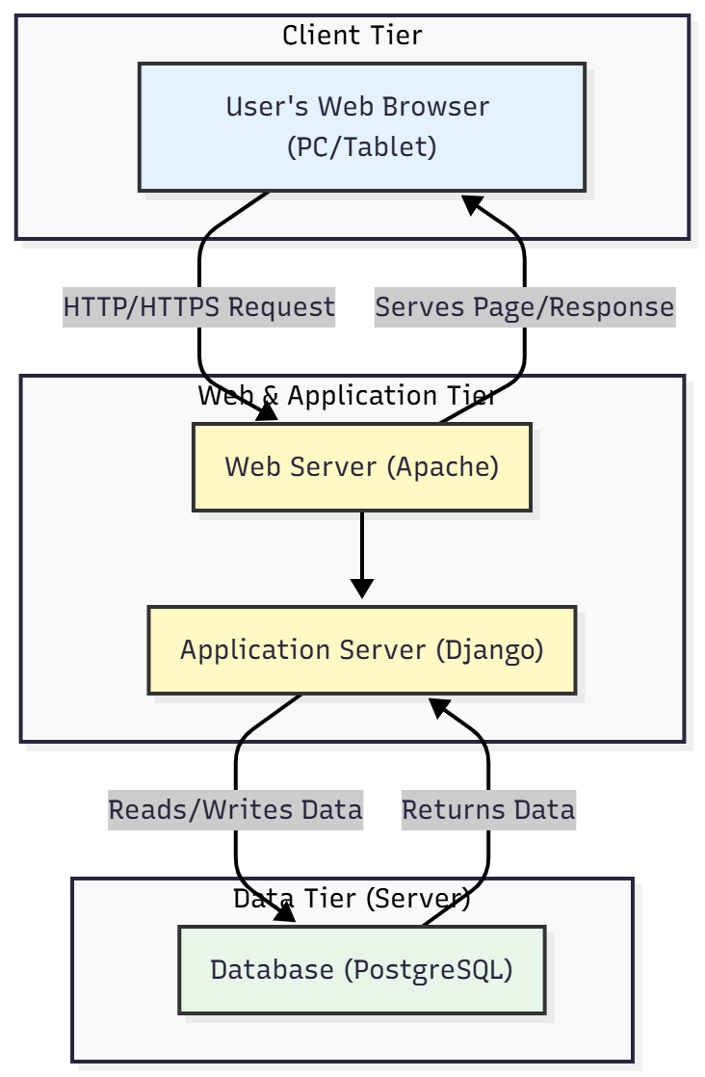
Figure 1 SYSTEM ARCHITECTURE DIAGRAM

1.6.3.2 Use Case Diagram
This Use Case diagram illustrates the system's functionality by showing what actions each type of user (actor) can perform. Department Staff can submit and track requests. Department Heads approve and track requests. Procurement Officers manage the core procurement workflow, including purchase orders and suppliers. Finally, the IT Administrator is responsible for managing user accounts and system settings.
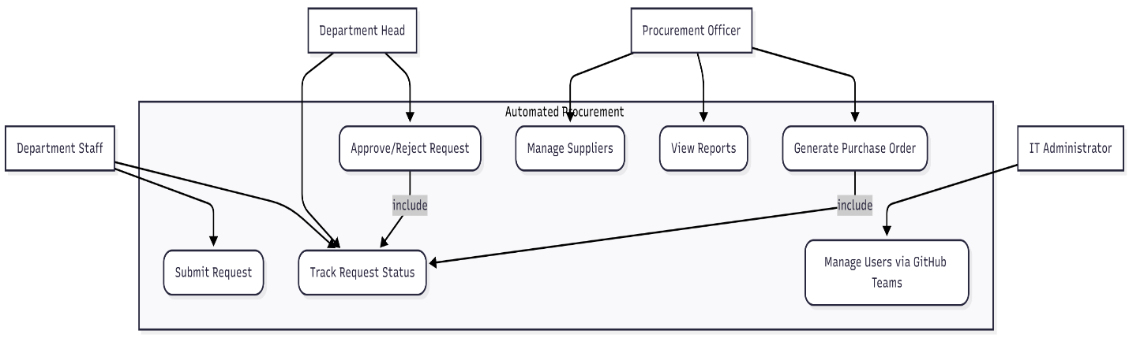
Figure 2 USE CASE DIAGRAM

1.6.3.3 Sequence Diagram
This Sequence Diagram details the step-by-step interaction for a successful procurement request and approval. It shows a Staff member submitting a request via the UI, which the System then saves to the Database and logs in GitHub. Subsequently, a Department Head approves the request, which triggers the system to update both the database and the corresponding GitHub issue, completing the workflow.
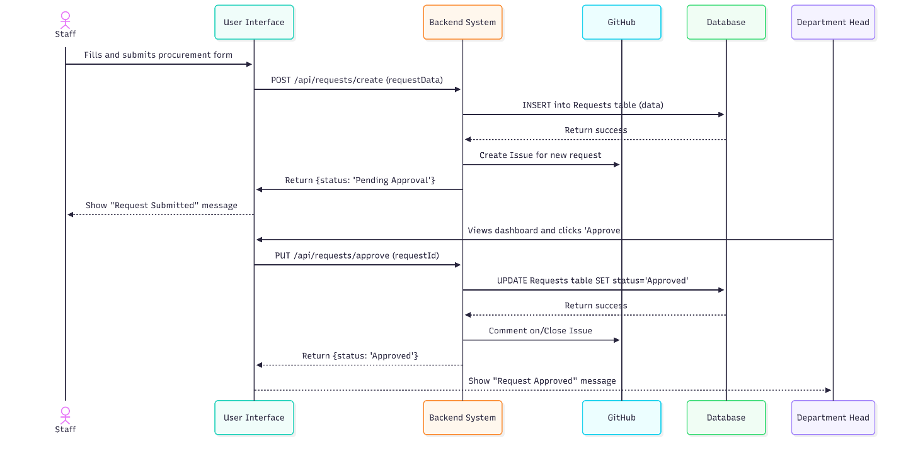
Figure 3 SEQUENCE DIAGRAM

1.6.3.4 User Interface Design
The User Interface (UI) will be designed to be clean, intuitive, and easy to navigate, ensuring hospital staff can use the system with minimal training. Adhering to a minimalist aesthetic, the design will prioritize clarity and function over complex visuals. A central dashboard will serve as the main screen for all users, providing a quick overview of pending tasks and the real-time status of their requests. The interface will be fully responsive, guaranteeing a seamless experience across desktops, tablets, and other devices, thereby maximizing accessibility and efficiency.

1.7 PROPOSED SOLUTION DEVELOPMENT
Overview This section describes how the procurement automation system will be developed from prototype (MVP) to pilot and how its artefacts will be organised and delivered. The approach continues to use Agile sprints, with an emphasis on secure design and automated quality gates (CI/CD pipelines). Deliverables for each phase are identified, and responsibilities for code, documentation and operational artefacts are specified.
Development phases
- Phase 0 — Preparation: detailed requirements clarification with stakeholders (procurement, biomedical engineering, department heads, IT), threat modelling and data classification.
- Phase 1 — MVP: deliver the core request submission, approval workflow, and request tracking (dashboard) and basic supplier management. Deploy as an internal pilot for select departments.
- Phase 2 — Extended features: purchase order automation, delivery confirmation, asset registration, reporting exports and role management.
- Phase 3 — Hardening & scale: performance tuning, security hardening, full backup & restore procedures, HA database and monitoring.
- Ongoing — Maintenance & evolution: regular updates, additional integrations (ERP, finance), and iterative improvements informed by pilot feedback.
Governance and stakeholder involvement
- Product Owner: hospital procurement lead (or nominated representative).
- Technical Lead: IT department lead (or contracted developer).
- Sprint Reviews: bi-weekly demos with stakeholders and end users; backlog refinement based on observed usage and metrics.
Compliance and ethics
- All development activities will comply with Ghana Data Protection Act (Act 843). The procurement system will enforce least-privilege access to sensitive procurement and financial data and maintain an auditable event log for accountability.

1.7.1 DEVELOPMENT TECHNOLOGY AND TOOLS SPECIFICATIONS

1.7.1.1 Software (Programming Language, IDE and runtime)
Primary stack (selected to match hospital and departmental constraints and existing decisions in the report):
- Presentation Tier (Frontend)
  - React (latest stable) for a single-page application (SPA) providing a responsive dashboard and forms.
  - Supporting libraries: React Router (navigation), Axios or Fetch API for HTTP, and a component library (Bootstrap or Material UI) styled for a hospital-appropriate theme.
- Logic Tier (Backend)
  - Python 3.10+ with Django framework and Django REST Framework (DRF) to implement RESTful APIs and business logic.
  - Authentication: Django’s auth system for role management; JWT or session authentication depending on deployment needs.
  - Logging: structured logging with JSON output; integration with a central log collector in production.
- Data Tier (Database)
  - PostgreSQL 13+ as the canonical relational store for requests, users, audit logs and asset records.
- DevOps & CI/CD
  - Git (version control) with feature branches and PR reviews.
  - GitHub Actions as CI: pipeline will run linting, static code analysis, unit tests, build artifacts, and integration tests. Successful runs produce artifacts and (on merge) may trigger staging deployment.
  - Containerization: Docker for local development and CI validation; optional Kubernetes manifests or Helm charts for production orchestration.
- Security & Quality Tools
  - Static analysis: Bandit (Python), flake8/black for style; npm/ESLint and Prettier for frontend.
  - Dependency scanning: Dependabot and Snyk (or similar) for vulnerability alerts.
  - SAST/DAST: run OWASP ZAP in CI for baseline dynamic scans; schedule deeper scans before production release.
- IDE and developer tooling
  - Backend: VS Code or PyCharm (recommended) with Python extensions.
  - Frontend: VS Code with ESLint, Prettier, React extensions.
  - Database tooling: pgAdmin or command-line psql for migrations and queries.
- Database migration & schema
  - Use Django migrations for schema evolution. Migrations are versioned in Git and applied by CI/CD or deployment scripts.

1.7.1.2 Hardware (for development and runtime) Development machines
- Workstations for developers: modern laptop/desktop with:
  - CPU: quad-core (or better)
  - RAM: 8–16 GB
  - Storage: SSD ≥ 256 GB
  - OS: Linux, macOS, or Windows with WSL2 for Linux compatibility Pilot (hospital internal)
- A single application server or small VM to host the backend and frontend (for internal pilot):
  - vCPU: 2
  - RAM: 4–8 GB
  - Storage: 100–250 GB SSD
  - Network: redundant NIC recommended; hostname with TLS certificate for internal access Production (recommended baseline)
- Web / API tier:
  - 2+ instances (for redundancy), each: 2–4 vCPU, 4–8 GB RAM, 50–100 GB SSD
- Database tier:
  - Managed PostgreSQL or dedicated VM: 4 vCPU, 8–16 GB RAM, 500+ GB SSD (depending on retention and attachments)
- Backup & ancillary storage:
  - Object storage (S3 or S3-compatible) for large attachments, backups and asset images
- Additional infrastructure
  - Load balancer (software or managed), reverse proxy (Nginx), and optionally WAF appliance or managed WAF service
Operational considerations
- Ensure hardware procurement and capacity planning match expected growth and reporting retention policies. Monitor resource utilisation and scale vertically or horizontally based on measured load.

1.7.2 NETWORK SPECIFICATIONS

1.7.2.1 Network specifications Transport security and access control
- TLS: enforce HTTPS for all external and internal web traffic (TLS 1.2 or 1.3). Redirect HTTP to HTTPS. Deploy valid certificates and configure HSTS after validation.
- Firewalling: permit only required ports (80/443 to public web tier if exposed; 22/management on bastion hosts only; DB port accessible only from application subnet).
- Network segmentation: separate web/API tier in a DMZ, application servers in an internal application subnet and PostgreSQL in a private data subnet. This prevents direct database access from the internet.
- Admin access: require VPN or bastion/jump host for SSH and admin interfaces. Limit access by IP allowlists where practical.
Email & external integrations
- Notifications: system email (approval notices, PO dispatch) must be sent via an authenticated, monitored transactional email service. Configure SPF, DKIM and DMARC for sending domains used by the hospital.
- External procurement systems: when integrating with third-party supplier APIs, use outbound allowlists, mutual TLS where supported, and tokenised API keys rotated regularly.
Monitoring, logging and backups
- Logging: centralise application and audit logs to a secure log store (with retention policy). Mask or avoid logging sensitive patient or financial data.
- Monitoring: collect metrics (response times, error rates, queue lengths) and configure alerts.
- Backups: perform regular database backups (daily full, hourly incremental) and test restores periodically.
Operational networking checklist
- Harden Nginx/Apache TLS configuration (strong ciphers, disable TLS 1.0/1.1).
- Enable network-level rate limiting on login endpoints.
- Ensure time synchronisation (NTP) across servers for reliable audit timestamps.

1.7.2.2 DEVELOPED SOLUTION AND ASSOCIATED CODE
The implementation will produce the following artefacts, versioned in the project source repository and packaged for review and deployment:
Repository & code layout (recommended)
- /backend/
  - Django project and apps: auth, procurement, suppliers, assets, notifications, reports
  - models.py, serializers.py, viewsets.py, permissions.py, tests/
  - migrations/
- /frontend/
  - React SPA: pages (dashboard, submit-request, approvals), components, services (API client), styles
  - build/ (CI build artifacts)
- /ops/
  - Dockerfile(s), docker-compose.yml for local development
  - Kubernetes manifests or Helm charts for staging/production (optional)
  - deployment scripts and CI templates
- /docs/
  - API documentation (OpenAPI / Swagger), architecture diagrams (Mermaid), runbook, security checklist
- /scripts/
  - database seed scripts (create initial admin, sample departments), backup/restore helpers
- /tests/
  - end-to-end test collections (Playwright/Cypress or Postman/Newman)
Core modules and responsibilities
- Authentication & Authorization
  - User model with roles (requestor, dept_head, procurement_officer, sys_admin) and RBAC enforcement in API layer.
- Procurement Workflow
  - Request model (item, qty, justification, department, attachments), Approval model (stage, approver, comments), and Audit model (events).
- Supplier & Purchase Order Management
  - Supplier records, PO generation, PO status lifecycle and attachments.
- Notifications & Logging
  - Email/SMS notification adapters (pluggable), audit logging for all state transitions.
- Reporting & Exports
  - API endpoints for aggregated metrics (requests by department, approval times, late orders) and CSV exports for audit and finance.
Supporting artefacts
- Database schema scripts and migration files (Django migrations).
- Seed data script (to create a safe initial admin account and sample department).
- OpenAPI specification generated from DRF viewsets for frontend and external integrators.
- README and operational runbook describing deployment steps, backup/restore and incident response for procurement-related incidents.
Packaging and handover
- The codebase, documentation and migration scripts will be packaged as release artefacts in the repository. CI will produce Docker images and optionally push them to a registry for staging. A deployment checklist will be provided to the hospital IT team for pilot rollout.

Figure 4 MAIN INTERFACE

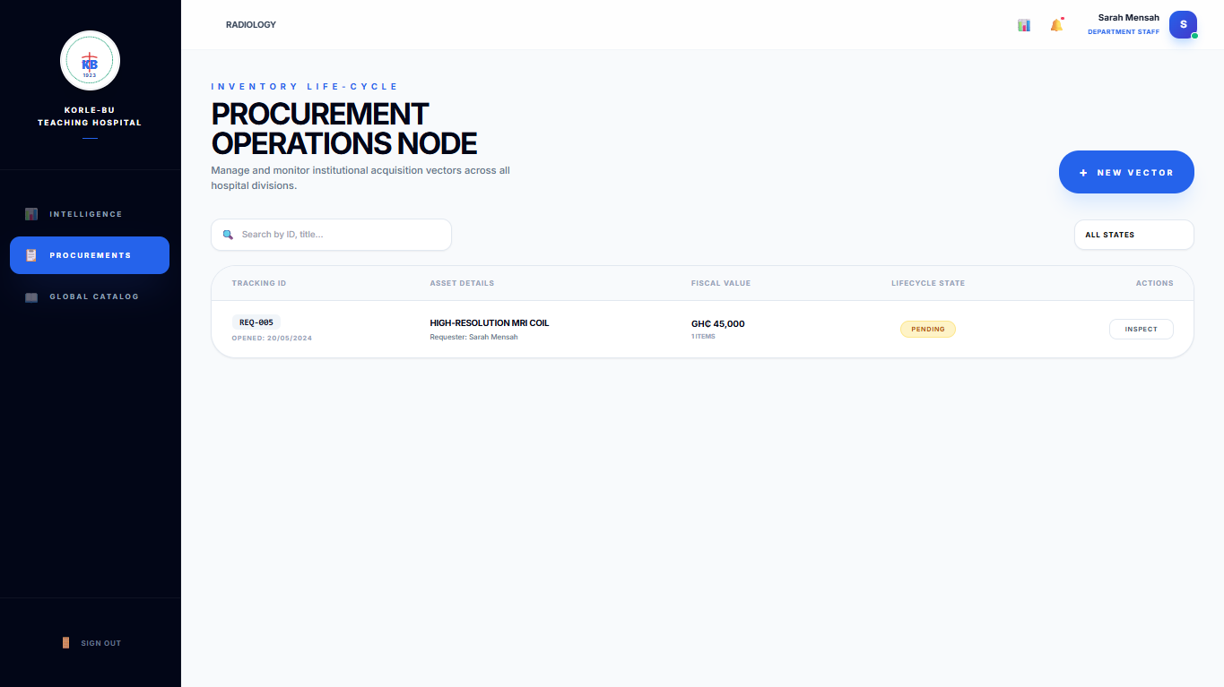
Figure 5 PROCUMENT PAGE

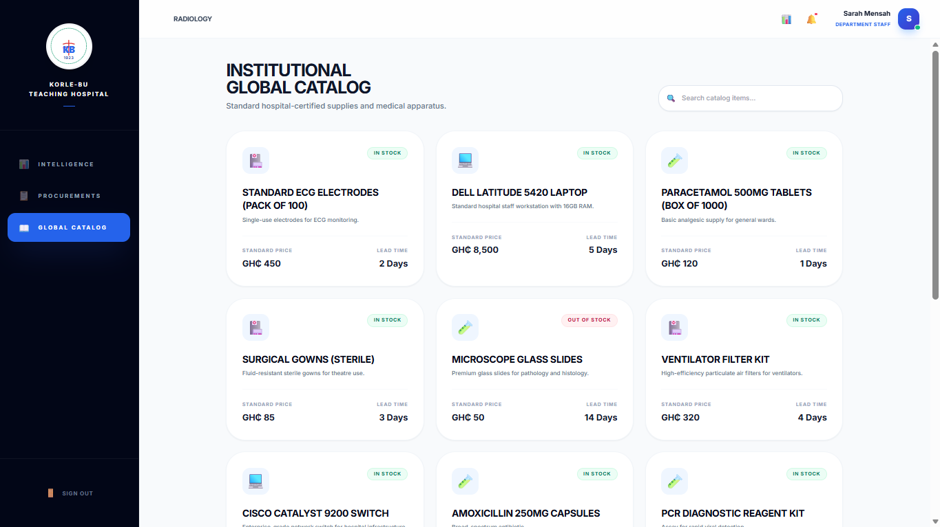
Figure 6 CATALOG PAGE

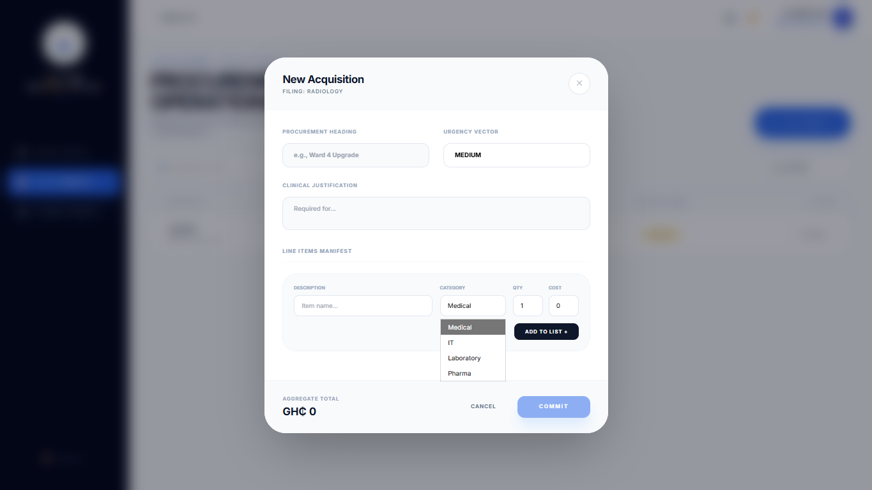
Figure 7 PROCUMENT ACQUISITION FORM

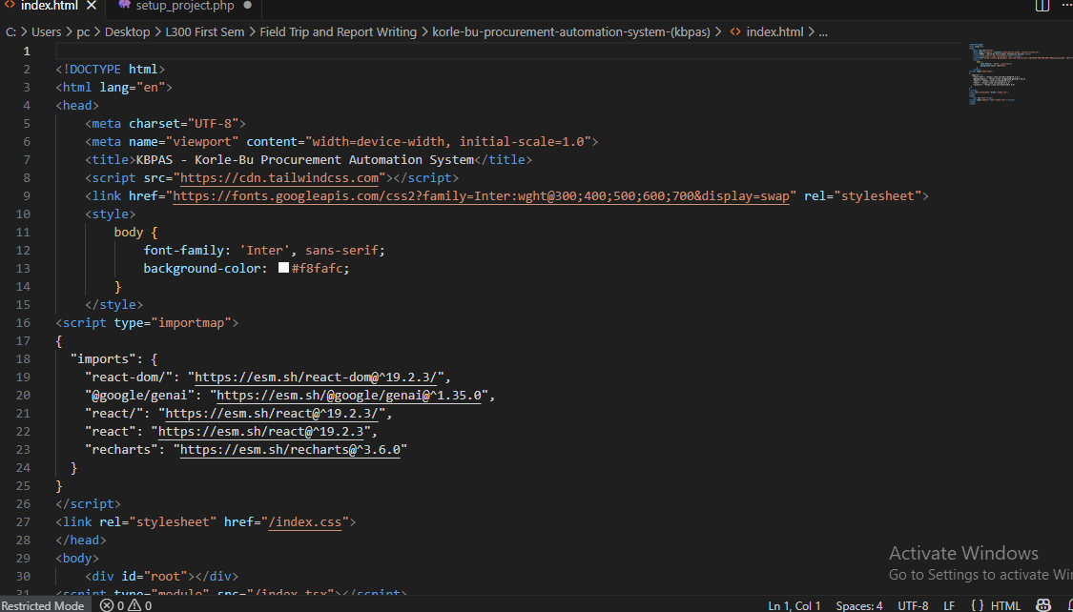
Figure 8 CODE FOR MAIN INTERFACE
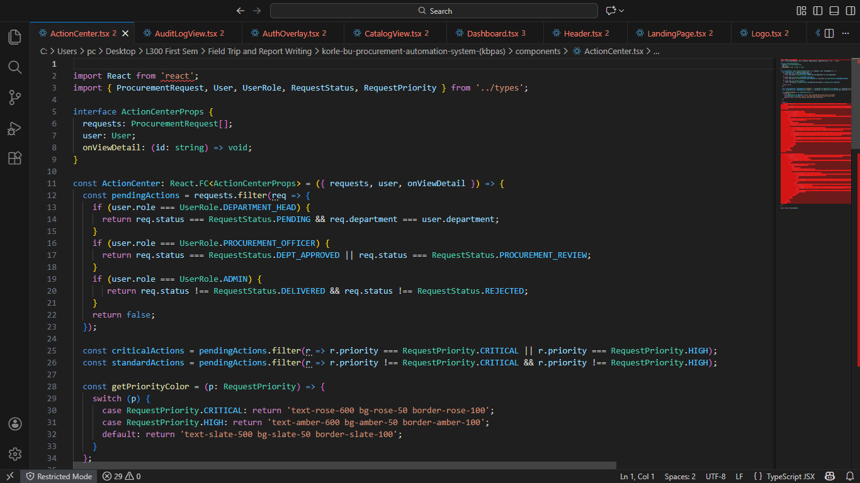
Figure 9 CODE FOR ACTION CENTER
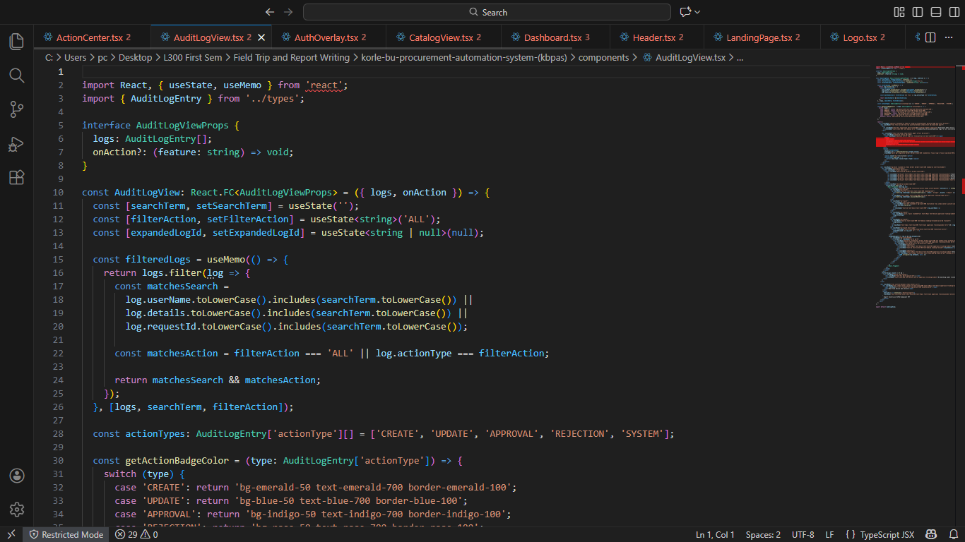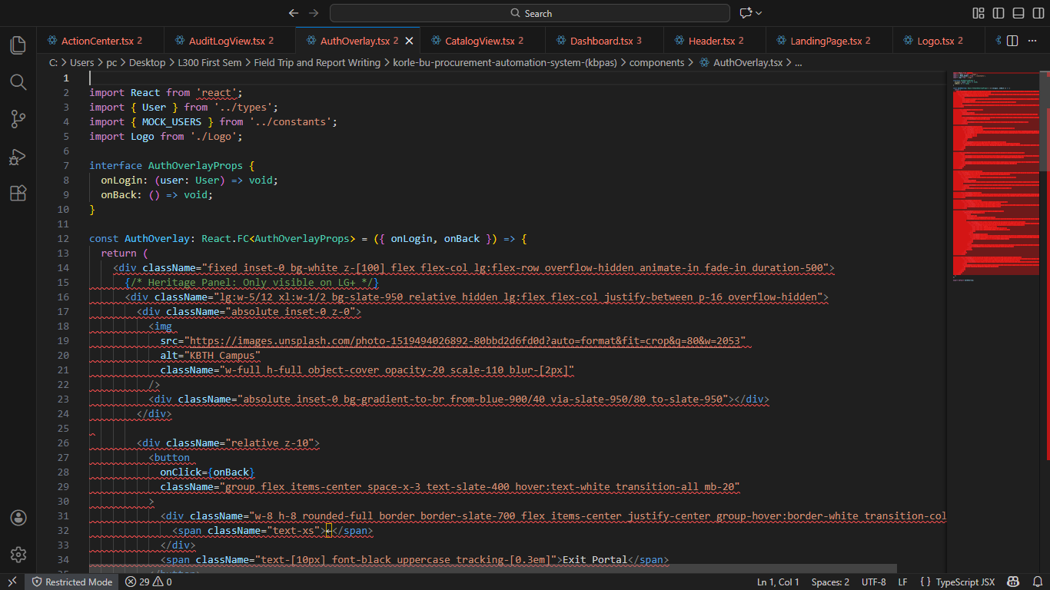
Figure 10 CODE FOR AUTHENTICATION
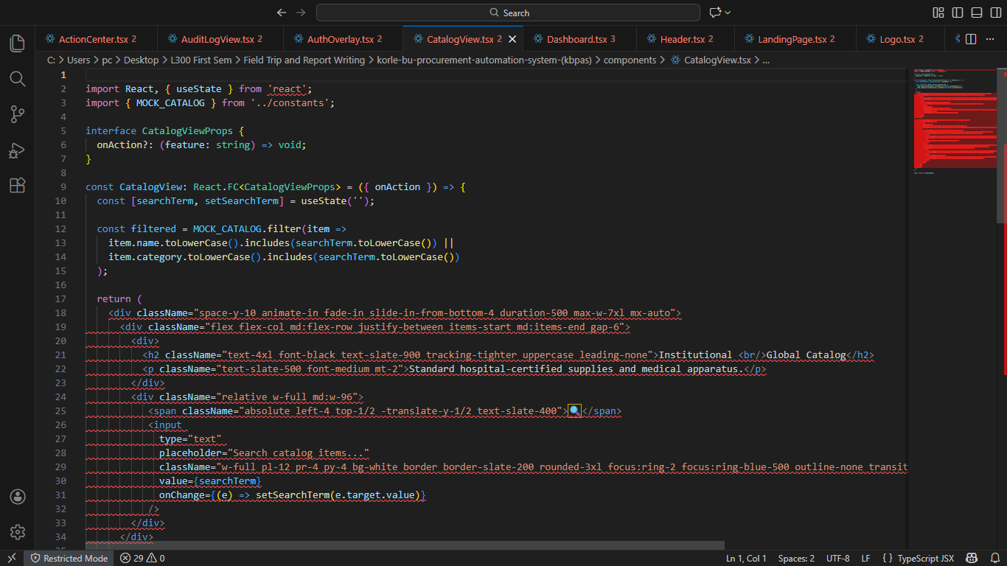
Figure 11 CODE FOR CATALOG
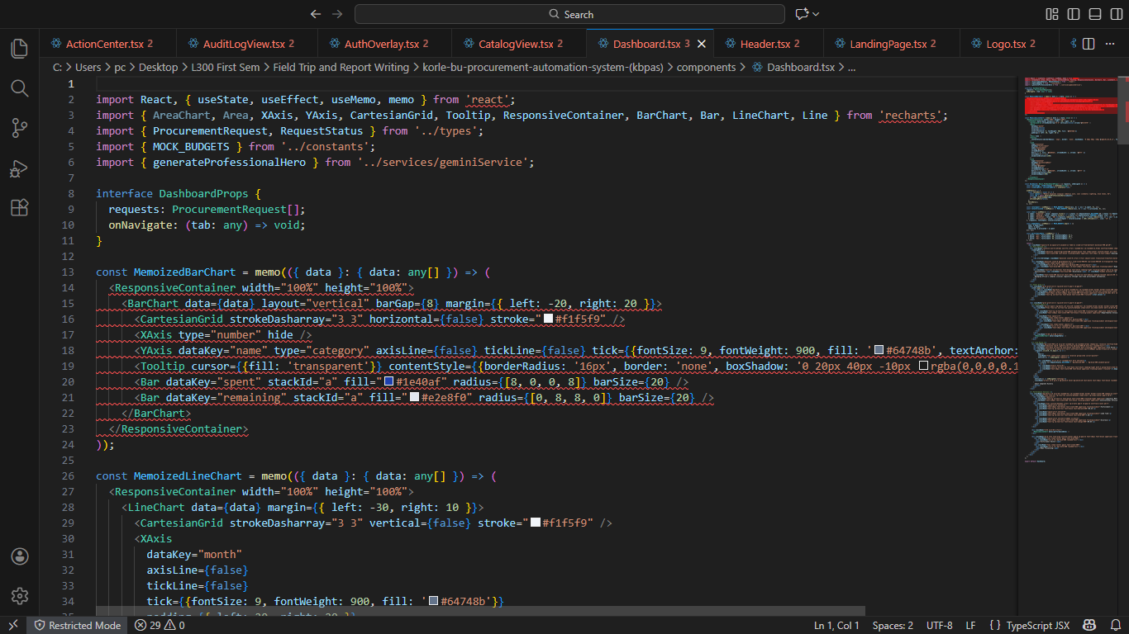
Figure 12 CODE FOR DASHBOARD
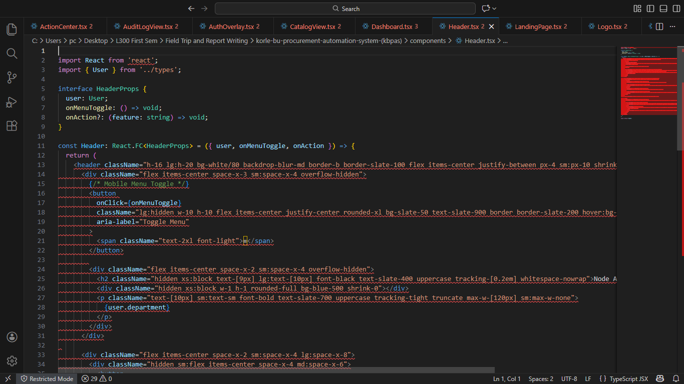
Figure 13 CODE FOR MENU HEADERS
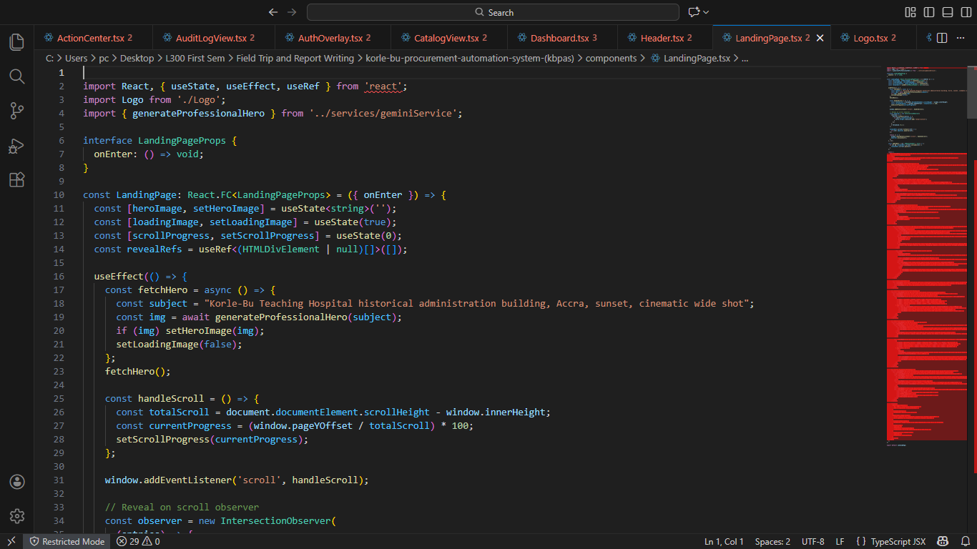
Figure 14 CODE FOR LANDING PAGE

Below is the link to the system
https://korle-bu-procurement-automation-system-kbpas-485418083812.us-west1.run.app

1.8 SYSTEM TESTING
Overview A comprehensive testing strategy is mandatory to ensure the system is functional, secure and performant before use in a clinical environment. Testing is organized into unit tests, integration tests and system (acceptance, security and performance) testing.

1.8.1 Unit Test Scope and purpose
- Unit tests validate the smallest testable components of the system in isolation (e.g., model methods, utility functions, scoring calculators and permission checks). They provide fast feedback to developers and form the foundation of CI quality gates.
Examples of unit tests
- Model validations: ensure Request and PO objects reject invalid states (negative quantity, missing department).
- Business logic: approval escalation logic, SLA calculation, estimated delivery date computation.
- Utility functions: attachment sanitisation, filename handling, date/time formatting and timezone handling.
- Permissions: unit tests verifying that users with different roles cannot perform restricted actions.
Tools and implementation
- Backend: pytest with Django integration or Django’s built-in test runner. Tests are run in CI on each push. Use factory patterns (factory_boy) for fixtures and mock external services (email adapter) when appropriate.
Acceptance criteria
- Unit tests cover critical business logic with high confidence; failing tests block merge into main branches.

1.8.2 Integration Testing Scope and purpose
- Integration tests verify that components interoperate correctly: backend API ↔ database, frontend ↔ API, and background jobs (notifications) ↔ external adapters. This level exercises realistic data flows and transaction boundaries.
Key integration scenarios
- Request lifecycle: user submits a request → DB persists → department head receives notification → department head approves → procurement officer creates PO → delivery confirmation updates asset register.
- Reporting pipeline: aggregated metrics calculation and CSV export.
- Email & notification pipeline: ensure notifications are queued and status updated if external SMTP is unavailable (retry and fallback behaviours).
Tools and approach
- Use a staging environment with a disposable database. Run integration tests using:
  - API tests driven by pytest or Postman/Newman collections.
  - Frontend→API E2E tests with Playwright or Cypress simulating user flows (submit request, approve).
  - Mock or sandbox external services for email delivery to avoid accidental external deliveries.
Acceptance criteria
- Integration tests pass in CI and on staging; data created during tests is cleaned up and does not affect production.

1.8.3 System Testing Scope and purpose
- System testing validates non-functional requirements: security resilience, performance, recoverability, accessibility and operational readiness.
Security testing
- Static analysis & dependency checks: run bandit, Snyk/Dependabot alerts and fix critical dependencies.
- Dynamic scanning: run OWASP ZAP / Burp Suite against staging to identify XSS, CSRF, SQLi, insecure cookies, and missing security headers.
- Penetration testing: schedule targeted penetration testing pre-production focusing on authentication, file uploads, API authorisation and report exports.
- Threat modelling: validate mitigations for identified threats (privilege escalation, data leakage).
Performance & load testing
- Define realistic pilot load and test using k6 or JMeter:
  - Simulate concurrent users performing common actions (submit request, view dashboard, approve) and ensure response times meet targets (<2s typical).
  - Identify and alleviate bottlenecks: DB indexes, query optimisation, caching (Redis) where necessary.
Reliability & resilience testing
- Backup & restore drills: perform full DB restore to validate RTO/RPO.
- Failover testing: bring down one app instance and validate load balancer and health checks perform as expected.
Accessibility & usability testing
- Mobile responsiveness checks and basic WCAG contrast/keyboard navigation validation for primary workflows (request submission, approval).
Operational acceptance testing (OAT)
- Stakeholder acceptance: departmental users perform acceptance test scripts; feedback is recorded as issues for sprint refinement.
- Security sign-off: security officer or internal auditor verifies that all high/critical vulnerabilities are remediated prior to production deployment.
Release gating criteria
- All unit and integration tests green in CI.
- No unresolved critical/high vulnerabilities from SAST/DAST or pentest.
- Performance under pilot load meets SLAs with acceptable resource utilisation.
- Administrative procedures documented (backup, restore, incident response).
- Stakeholder acceptance confirmed for pilot departments.

Reference
Fowler, M. (2004) UML Distilled: A Brief Guide to the Standard Object Modeling Language. 3rd edn. Boston: Addison-Wesley Professional.
Fowler, M. (2006) Continuous Integration. Available at: https://martinfowler.com/articles/continuousIntegration.html (Accessed: 5 December 2025).
Government of Ghana (2012) Data Protection Act, 2012 (Act 843). Accra: Ghana Publishing Company.
Nielsen, J. (1994) 10 Usability Heuristics for User Interface Design. Available at: https://www.nngroup.com/articles/ten-usability-heuristics/ (Accessed: 5 December 2025).
Sommerville, I. (2016) Software Engineering. 10th edn. Harlow: Pearson Education.

